ELEGANCE SALON
Salon Management System
User Guide
A guide for clients and salon staff: how to browse services, book and manage appointments, and use the staff portal.
Project detail
Project | eProject: Salon Management (PHP + MySQL)
Supervisor | Miss Anumta Alam
Batch | 2512E1
Group | ______________________

Serial No. | Enrollment Number | Student Name
1 | 1717572 | Ayesha Farooq
2 | 1717573 | Ibra Ali
3 | 1718286 | Muhammad Qasim
4 | 1718218 | Wania Kaleem

Version 1.0 | October 2026

Contents
1 Introduction
2 Website Layout (Header, Sidebar, Footer)
3 Public Website
4 Booking an Appointment
5 Managing an Existing Booking
6 Staff Sign In
7 Admin Portal
8 Receptionist Portal
9 Stylist Portal
10 Additional Features
11 Troubleshooting and FAQ
12 Page Documentation Sheets

1 Introduction
Elegance Salon is a web application for a beauty salon that offers hair styling, manicures, pedicures, facials and makeup. It has two parts: a public website where clients view services and book online, and a staff area where the team manages appointments, clients, stock, payments and reports.

1.1 Who uses the system
User | Needs an account? | What they can do
Client (visitor) | No | Browse services, book an appointment, change or cancel it with a reference number and phone, send feedback, view contact details
Admin | Yes | Everything: all modules, staff and accounts, services, settings, reports
Receptionist | Yes | Appointments, calendar, clients, inventory, payments and invoices, feedback
Stylist | Yes | Own appointments and own calendar only

1.2 Before you start
- Use a modern browser (Chrome, Edge, Firefox or Safari) with JavaScript enabled. Free time slots are loaded by JavaScript.
- Public website address: http://localhost/elegance-salon/ (on a live server, use the salon’s own domain).
- Staff sign-in address: http://localhost/elegance-salon/admin/login.php.

1.3 Test accounts
The administrator account is created once by the person who installs the site (see the Developer Guide). Receptionist and stylist accounts are then created by the admin on the Accounts page. Write the accounts used for evaluation here:
Role | Email | Password
Admin
Receptionist
Stylist

2 Website Layout

2.1 Global header and navigation
The header is shown on every public page. The logo returns to the Home page. The menu contains:
Menu item | Opens
Home | Introduction to the salon, popular services, team
Services | Full price list grouped by category
Contact | Phone, email, address and opening hours
Feedback | Rating and comment form
Manage booking | Change or cancel a booking with reference and phone
Log in / Sign up | Account links shown in the header
Book now | Online booking form (always visible as a button)
On phones the menu collapses behind a menu button in the top right corner.
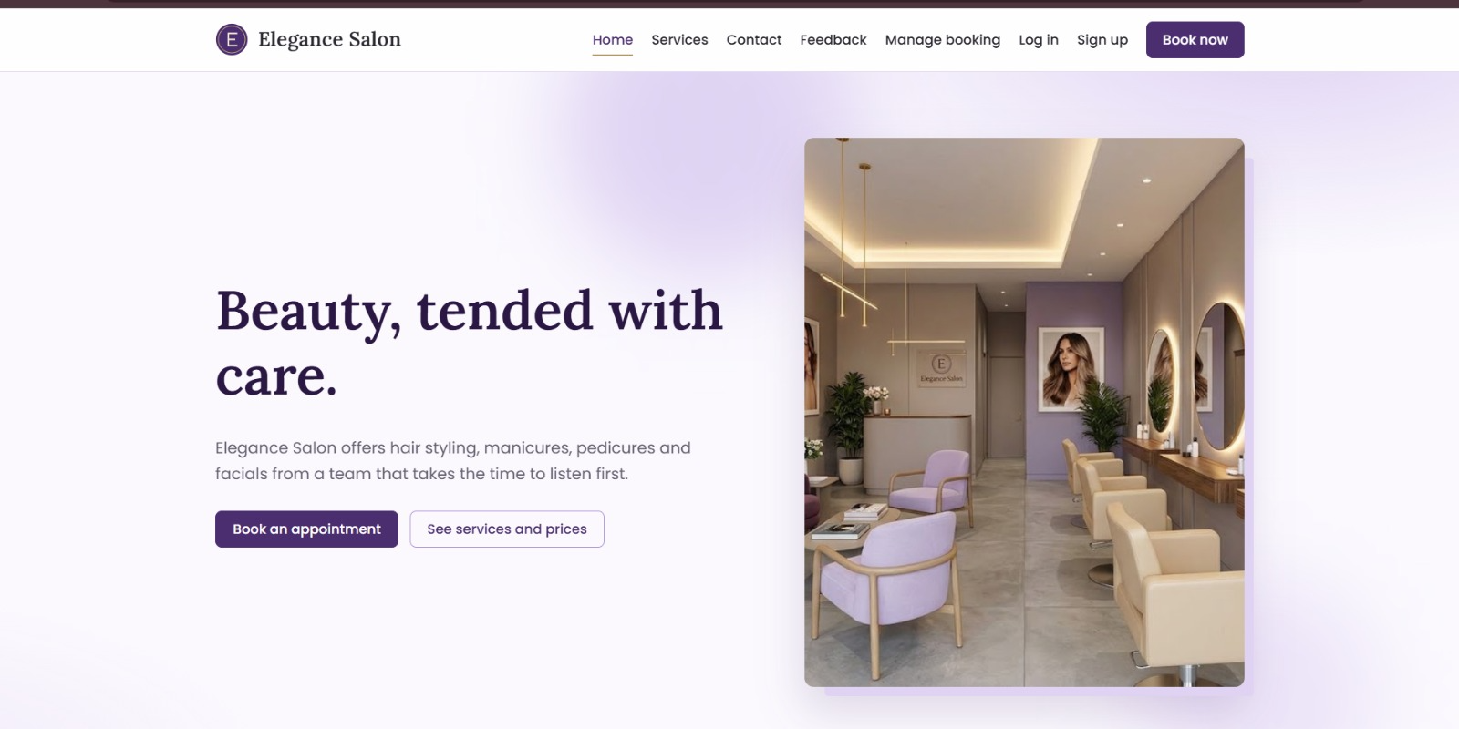
Figure 1: Home page with the global header

2.2 Staff sidebar (after sign in)
After signing in, staff see a left sidebar. Only the modules allowed for the signed-in role are listed. The bottom of the sidebar shows the current role. In the top bar, View website opens the public site in a new tab, and the profile menu (your initial) shows your name and email with a Sign out button.
Module | Admin | Receptionist | Stylist
Dashboard | Yes | Yes | Yes (own)
Appointments | Yes | Yes | Own only
Calendar | Yes | Yes | Own only
Clients | Yes | Yes | No
Services | Yes | No | No
Staff | Yes | No | No
Inventory | Yes | Yes | No
Payments | Yes | Yes | No
Reports | Yes | No | No
Feedback | Yes | Yes | No
Notifications | Yes | No | No
Accounts | Yes | No | No
Settings | Yes | No | No

2.3 Footer
The dark footer at the bottom of every public page shows the salon name and tagline, the address and opening hours (Visit), and the phone number and email (Contact). These details are edited by the admin on the Settings page, so they always match the salon’s current information.

3 Public Website

3.1 Home page
The Home page introduces the salon with a headline, a short description and a photo. Two buttons are available: Book an appointment and See services and prices. Further down are the Popular services (each with a Book button), a short “A calm place to look after yourself” section, Meet the team, and a final Ready when you are call to action.

3.2 Services page
Services and prices lists every active service grouped by category (Hair, Nails, Skin, Makeup). Each card shows the name, description, duration and price. Pressing Book opens the booking form with that service already selected.

3.3 Contact page
The Contact us page shows the salon’s phone, email, address and opening hours, and links to the feedback form.

3.4 Feedback page
- Open Feedback in the header.
- Enter your name (and optionally your email).
- Choose a rating from 1 to 5.
- Write your comment (up to 2000 characters) and press the submit button.
A thank-you message confirms the feedback was saved. To prevent spam, a second submission within 30 seconds is refused. Staff read feedback in the admin area.

4 Booking an Appointment
Anyone can book online without creating an account. Open Book now in the header (or any Book button on the site).
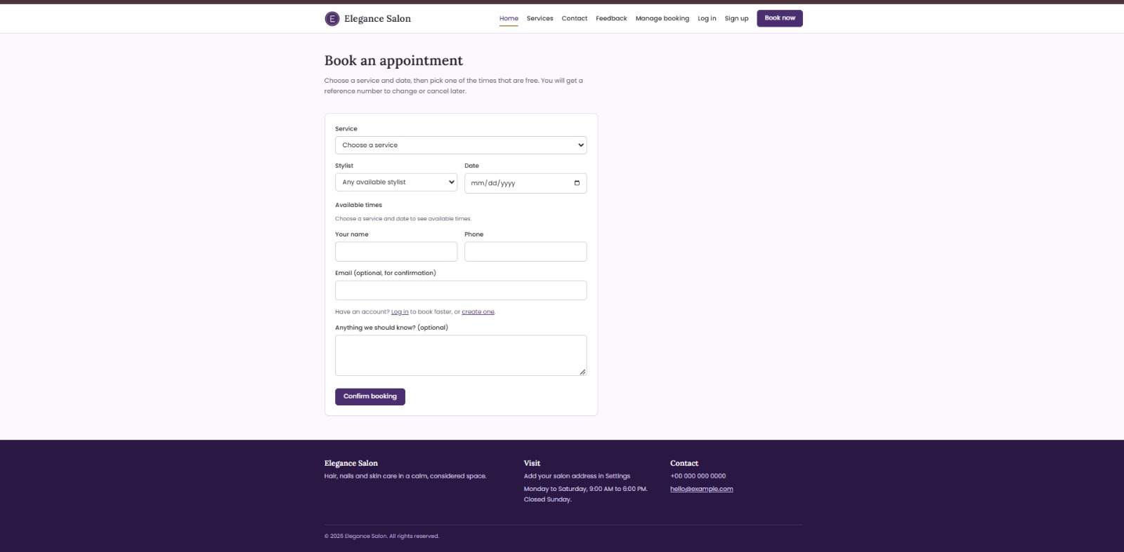
Figure 2: Book an appointment form

Steps
- Choose a Service. The Stylist list then shows only the stylists who perform that service.
- Optionally choose a Stylist, or leave Any available stylist.
- Pick a Date. You can book from the minimum notice time (2 hours by default) up to 60 days ahead (both set by the admin).
- Under Available times, tap a free time. Times already taken, outside the stylist’s working hours or too soon are not shown.
- Enter Your name and Phone. Email is optional but needed to receive a confirmation email.
- Add any note for the salon (optional) and press Confirm booking.

Confirmation
The You are booked in page shows your booking details and a reference number that starts with ES (for example ES4F2A1C). Keep it: with your phone number it is the only way to change or cancel online. Two buttons are offered: Add to calendar (downloads an .ics file that opens in Google, Apple or Outlook calendars) and Manage booking.
If the chosen time is taken by someone else a moment earlier, the form shows “Sorry, that time was just taken” and you can pick another time. Double bookings are not possible.

5 Managing an Existing Booking
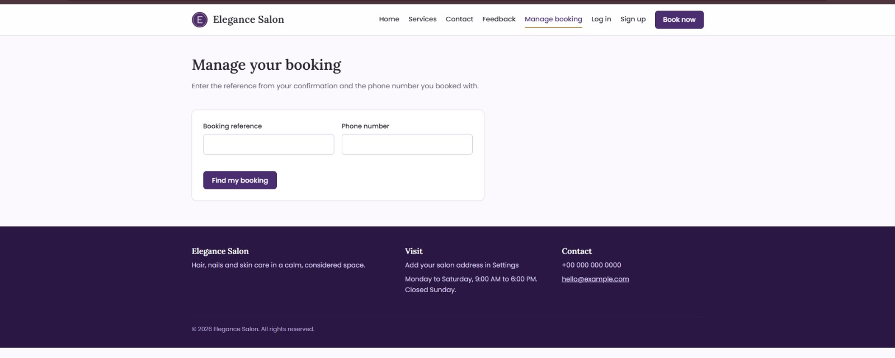
Figure 3: Manage your booking
- Open Manage booking in the header.
- Enter the Booking reference and the Phone number used when booking.
- Press Find my booking. The booking details appear.
- To move it, choose a new date and time and confirm. To cancel, press the cancel button and confirm.
Changes are allowed only while the booking is confirmed and still in the future. Otherwise the page asks you to call the salon. After 8 wrong attempts the page locks for 5 minutes. If an email was given, a change or cancellation email is sent.

6 Staff Sign In

6.1 Signing in
- Open /admin/login.php.
- Enter your email and password and press the sign-in button.
- You arrive at the Dashboard. Your sidebar shows only the modules your role allows.
After 5 wrong attempts, sign-in is locked for 5 minutes. Accounts marked inactive cannot sign in.

6.2 Signing out
Open the profile menu in the top right corner and press Sign out. Always sign out on shared computers.

6.3 Registration and password reset
- Client registration: not required for booking.
- Staff accounts: only an admin can create them (Accounts > Add account). There is no public staff registration.
- Forgotten password: there is no self-service reset. Ask the admin to open Accounts, edit your account and enter a new password (at least 10 characters). Leaving the field empty keeps the old one.
- First administrator: created once on setup.php. That page stops working as soon as any account exists.

7 Admin Portal
The admin sees all 13 modules. Each is described below.

7.1 Dashboard
Today’s date, number of appointments today, confirmed appointments in the next 7 days, total clients, and revenue this month. Today’s schedule lists each client, service, stylist and status. Needs attention shows low-stock items and completed appointments that have no payment yet.

7.2 Appointments
Search by client name or reference, filter by status and by time (upcoming or other ranges) and by stylist. Add an appointment for a walk-in or phone booking, edit it, or change its status to Completed, Cancelled or No show. Cancelling emails the client when an email exists.

7.3 Calendar
A week view (Monday to Sunday) of all appointments. Use Previous week and Next week; admins and receptionists can filter by stylist.

7.4 Clients
Search by name, phone or email. Open a client to see details, preferences and the full service history. Add or edit clients and record a preferred stylist. Only admins can delete, and only clients with no appointments or payments.

7.5 Services
Add, edit or remove services: name, category, description, price, duration, photo upload, featured on Home, and active or hidden.

7.6 Staff
Profiles with role title, contact details, bio and photo, commission rate, services offered and weekly working hours (these hours decide which times clients can book). A team member with appointments cannot be deleted; mark them inactive instead.

7.7 Inventory
Stock list with quantity, reorder level, unit cost and supplier details. Use the Adjust control to add or remove stock (stock cannot go below zero). Items at or below the reorder level are flagged, and Purchase order produces a printable restock list with suggested quantities and totals.

7.8 Payments
Record a payment against a completed appointment or a walk-in sale: amount, method (cash, card, online) and status (paid, pending, refunded). Each payment gets an invoice number such as INV-2026-00001. Open it for a printable receipt. A second payment on the same appointment is blocked unless the first is refunded.

7.9 Reports
Choose a date range (default: this month). See appointment counts by status, paid and pending amounts, new clients, most booked services, busiest hours, stylist revenue and commission, and low stock. The page can be printed.

7.10 Feedback
Read all client ratings and comments, newest first.

7.11 Notifications
Log of every confirmation, change, cancellation and reminder email, with a delivery column showing Sent or Not sent.

7.12 Accounts
Create, edit and delete staff logins. Choose a role (admin, receptionist, stylist), link a stylist login to a staff profile, set active or inactive, and see last sign-in. You cannot delete or demote your own account.

7.13 Settings
Salon name, tagline, phone, email, address, opening-hours text, currency symbol, time-slot length (10, 15, 20, 30, 45 or 60 minutes), minimum booking notice (0 to 168 hours) and booking window (1 to 365 days).

8 Receptionist Portal
Receptionists see: Dashboard, Appointments, Calendar, Clients, Inventory, Payments and Feedback. They use these exactly as described in Section 7. Typical daily work:
- Check the Dashboard for today’s schedule and items needing attention.
- Create appointments for phone and walk-in clients (Appointments > Add).
- Mark appointments Completed, Cancelled or No show.
- Record the payment for each completed visit and print the invoice.
- Update stock levels and print a purchase order when items run low.
Receptionists cannot open Services, Staff, Reports, Notifications, Accounts or Settings, and cannot delete clients. Opening those pages shows a “Not allowed” message.

9 Stylist Portal
Stylists see: Dashboard, Appointments and Calendar, limited to their own appointments. The stylist account must be linked to a staff profile by the admin; otherwise no appointments appear. A stylist can open the appointment list, view the weekly calendar and update the status of their own appointments.

10 Additional Features
Feature | How it works
Email notifications | Confirmation, change and cancellation emails are sent when the client gives an email address. Every attempt is logged on the Notifications page. On a computer without a mail server the log shows Not sent.
Reminders | A daily scheduled task emails clients and stylists about tomorrow’s confirmed appointments.
Calendar export | The Add to calendar button downloads an .ics file that works with Google, Apple and Outlook calendars. It is a one-time export, not a live sync.
Search, filters and paging | Appointments, clients and payments have search boxes and filters. Long lists are split into pages.
Print | Invoices, purchase orders and reports have a print view.
Online payment | Not available. Payments are recorded by staff after the client pays at the salon.
Chatbot, video tutorials | Not implemented in this version. Use the Contact page for help.

11 Troubleshooting and FAQ
Problem | What to do
No times are shown | Check that a service and a date are selected. The date must be within the booking window, the stylist must work that weekday, and the day may be fully booked. Try another date or “Any available stylist”.
I lost my reference number | Look in your confirmation email, or call the salon. Staff can find it on the Appointments page.
“We could not find a booking” | Check the reference (letters and numbers) and enter the same phone number used when booking.
I cannot change my booking online | Only future, confirmed bookings can be changed online. Call the salon.
Staff sign-in fails | Check email and password. After 5 failures wait 5 minutes. Ask the admin to confirm the account is active.
“Not allowed” message | Your role does not include that page. Ask the admin if you need access.
A stylist sees no appointments | The admin must link the stylist’s account to a staff profile (Accounts > Edit).
Emails are not arriving | Emails need a mail server on the host. Check the Notifications page for Sent or Not sent.

12 Page Documentation Sheets
One sheet per important page, following the project template. Pages marked with a dashed box need a screenshot from the running system.

Home Page
Field | Details
Page / Feature Name | Home Page
Purpose | Introduce the salon and lead visitors to services and booking.
How to Access This Page | Open the website address, or press Home in the header.
Steps to Use | 1. Read the introduction.  2. Press Book an appointment or See services and prices.  3. Scroll to see popular services and the team.
Expected Result | The visitor reaches the booking form or the price list.

Home page

Book an Appointment
Field | Details
Page / Feature Name | Book an Appointment
Purpose | Let a client reserve a free time without an account.
How to Access This Page | Header > Book now.
Steps to Use | 1. Select service, stylist and date.  2. Pick a free time.  3. Enter name and phone.  4. Press Confirm booking.
Expected Result | A confirmation page shows the reference number and an Add to calendar button.

Book an appointment

Manage Booking
Field | Details
Page / Feature Name | Manage Booking
Purpose | Change or cancel a booking using reference and phone.
How to Access This Page | Header > Manage booking.
Steps to Use | 1. Enter reference and phone.  2. Press Find my booking.  3. Reschedule or cancel.
Expected Result | The booking is updated and a confirmation message is shown.

Manage booking

Services Page
Field | Details
Page / Feature Name | Services Page
Purpose | Show the price list.
How to Access This Page | Header > Services.
Steps to Use | 1. Browse by category.  2. Press Book on a service.
Expected Result | The booking form opens with the service selected.

[ Insert screenshot ]
Services page

Feedback Page
Field | Details
Page / Feature Name | Feedback Page
Purpose | Collect client opinions.
How to Access This Page | Header > Feedback.
Steps to Use | 1. Enter name, rating and comment.  2. Submit.
Expected Result | A thank-you message appears and the feedback is stored.

[ Insert screenshot ]
Feedback page

Staff Sign In
Field | Details
Page / Feature Name | Staff Sign In
Purpose | Secure access for staff.
How to Access This Page | Open /admin/login.php.
Steps to Use | 1. Enter email and password.  2. Press sign in.
Expected Result | The Dashboard opens with the modules for the user’s role.

[ Insert screenshot ]
Staff sign-in page

Admin Dashboard
Field | Details
Page / Feature Name | Admin Dashboard
Purpose | Daily overview.
How to Access This Page | Sign in, or sidebar > Dashboard.
Steps to Use | 1. Read the counts.  2. Review today’s schedule.  3. Open items under Needs attention.
Expected Result | Today’s appointments, revenue and alerts are visible at a glance.

[ Insert screenshot ]
Admin dashboard

Appointments
Field | Details
Page / Feature Name | Appointments
Purpose | Create and manage bookings.
How to Access This Page | Sidebar > Appointments.
Steps to Use | 1. Search or filter.  2. Add or edit an appointment.  3. Change the status.
Expected Result | The list and the client’s history are updated.

[ Insert screenshot ]
Appointments list

Calendar
Field | Details
Page / Feature Name | Calendar
Purpose | See the week at a glance.
How to Access This Page | Sidebar > Calendar.
Steps to Use | 1. Use Previous or Next week.  2. Filter by stylist.
Expected Result | Appointments appear on their day.

[ Insert screenshot ]
Week calendar

Clients
Field | Details
Page / Feature Name | Clients
Purpose | Maintain client records.
How to Access This Page | Sidebar > Clients.
Steps to Use | 1. Search a client.  2. Open for service history.  3. Edit preferences.
Expected Result | The client profile shows all past visits.

[ Insert screenshot ]
Clients page

Services (Admin)
Field | Details
Page / Feature Name | Services (Admin)
Purpose | Maintain the service menu.
How to Access This Page | Sidebar > Services.
Steps to Use | 1. Add or edit a service.  2. Upload a photo.  3. Save.
Expected Result | The public Services page shows the change.

[ Insert screenshot ]
Services admin

Staff
Field | Details
Page / Feature Name | Staff
Purpose | Manage stylists, hours and commission.
How to Access This Page | Sidebar > Staff.
Steps to Use | 1. Add or edit a profile.  2. Tick the services offered.  3. Set weekly hours and commission.
Expected Result | Clients can book only during the stylist’s working hours.

[ Insert screenshot ]
Staff page

Inventory and Purchase Order
Field | Details
Page / Feature Name | Inventory and Purchase Order
Purpose | Track supplies and restock.
How to Access This Page | Sidebar > Inventory.
Steps to Use | 1. Adjust quantities.  2. Press Purchase order.  3. Print.
Expected Result | A printable restock list is produced.

[ Insert screenshot ]
Inventory page

Payments and Invoice
Field | Details
Page / Feature Name | Payments and Invoice
Purpose | Record payments and print receipts.
How to Access This Page | Sidebar > Payments.
Steps to Use | 1. Add payment.  2. Select appointment or walk-in.  3. Open the invoice number to print.
Expected Result | A numbered invoice such as INV-2026-00001 is created.

[ Insert screenshot ]
Payments page

Reports
Field | Details
Page / Feature Name | Reports
Purpose | Review business performance.
How to Access This Page | Sidebar > Reports.
Steps to Use | 1. Choose a date range.  2. Review the figures.  3. Print.
Expected Result | Statistics for the period are shown.

[ Insert screenshot ]
Reports page

Accounts and Settings
Field | Details
Page / Feature Name | Accounts and Settings
Purpose | Manage logins and salon details.
How to Access This Page | Sidebar > Accounts or Settings.
Steps to Use | 1. Create accounts with a role.  2. Update salon details and booking rules.
Expected Result | Changes apply immediately across the website.

[ Insert screenshot ]
Accounts / Settings page

